We’ve Got Spirit!
How About You?

Show your school spirit with some Spirit Wear! It’s a great way to show your pride in your school, especially if you moved to a new school or if you are new to the district. We are offering t-shirts, sweatshirts, flannel pants and a few new items with either the Albright Vikings or Salt Creek/Swartz Mini Vikings.

To order your district 48 Spirit Wear just complete the order form, put the order form and payment in an envelope marked “FTC Spirit Wear” and send it to school with your child before the order deadline date.

Please return your order by Friday May 6th, 2016.
Orders will be delivered to your student on Friday May 20th, 2016.

If you have any questions or concerns, please contact Kelly Altott – (kaltott@saltcreek48.org).

Spirit wear sales are coordinated through FTC, the parent-teacher organization for Salt Creek District 48. All proceeds go for the benefit of the schools. Please make checks payable to “FTC”.

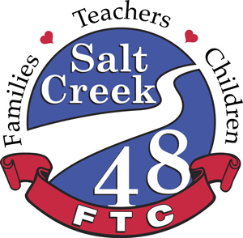

Albright Middle School • Stella May Swartz Elementary • Salt Creek Primary

